Sex identification and sampling

1, Appearance
Male tubesnout pelvic fins are conspicuous red in color and are thought to remain that way year round. Other reported coloration along the length of the body and the head is not notable on the aquarium living tubesnouts in our experience.

Artist rendering of male (top) and female (bottom)

A live tubesnout

If it’s hard to tell the male ones from the others through this way, don’t be frustrated! We have a plan B here.

2, Dissection

2.1 Euthanasia
https://www.zoology.ubc.ca/~schluter/wordpress/stickleback/measure/
You will need the following materials:

MS-222 (Tricaine Methane Sulfonate)
Sodium bicarbonate (baking soda)
Forceps or long Tweezers
Spatula
1000 ml glass beaker
pH test kit

Procedure:
Make a desired volume of MS-222 solution in the beaker (concentration of 0.5g/L) and buffer the solution to pH of 7-7.5 with sodium bicarbonate (0.5-1g/L). Wear protective clothing, gloves, and goggles when handling MS-222 powder. If possible, work inside a fume hood to prepare solution
Place fish in the solution until death is achieved. Verify the animal is dead before disposing or preserving the carcass by monitoring the absence of respiratory or opercular movement for at least 3 minutes.

Additional notes:

Dispose of MS-222 waste by flushing down the drain to a sanitary sewer with an excess of water.
If in a remote location where a sewer may not be readily available, further dilute the solution with water and dump wastes on land in a location away from water.
Do not discard MS-222 directly into surface water, storm water or catch basins.
MS-222 is a light sensitive chemical and should be stored in a dark container or in a cabinet/drawer.

2.2 sampling

You will likely need a dissecting scope, several pairs of autoclaved scissors, tweezers, scalpels, petri dishes, as well as some paper towel, foil, and liquid nitrogen.
To avoid contamination from the gut contents, I highly recommend cut the muscle tissue before opening the abdomen.

2.2.1 Use the 70% EtOH to clean the surface of the euthanized fish.

2.2.2 Separate the muscle from the tail to the position near the cloacal opening and cut if off.

2.2.3 Remove the skin carefully. Repeat 2.2.2 on the other side. Now you obtained two perfect tubesnout filets!

2.2.4 Wrap the two filets with a single piece of foil, number each the foil. Sink the small foil packet into liquid nitrogen to flash freeze the tissue inside, and store the packet at -80 before shipping.

  - Gonads observation (works on those individuals that are sexually mature.)
Follow any fish dissection video on youtube… Operation under a dissecting scope would be better.
Open the body cavity, and push aside other organs to expose the gonads. In this picture, the stomach is on the top, which is frequently mistaken for ovary.
Here are the typical male and female gonads.
Male (with urinary bladder, one testis is removed by me in the second image)
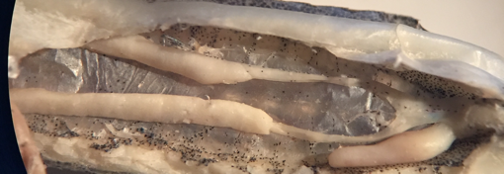
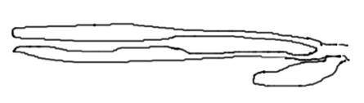
Female
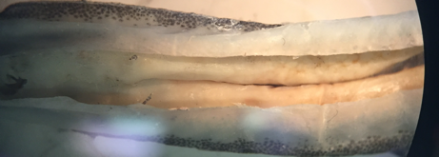
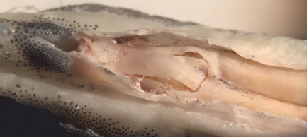
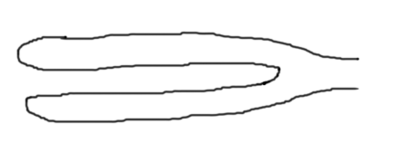
Zoom in so you will be able to see the mature egg.

