Principles:
• Do not vortex gDNA prior to shearing
• Avoid excessive pipetting
• Avoid multiple freeze/thaw cycles
• Avoid exposure to excessive heat

Input amount of gDNA, 20kb insert-size required by Pacbio: 7.5 μg to 10 μg

QIAGEN Genomic-tip

Pure (free from RNA or other organic and inorganic contaminants), high-molecular-weight DNA is required to prepare size-selected ~20 kb SMRTbell templates.
Quantification with both a NanoDrop spectrophotometer and a Qubit fluorometer helps characterize DNA quality.
If the gDNA concentration, as determined by the Qubit fluorometer, is significantly less than the concentration determined by the NanoDrop spectrophotometer, this indicates presence of contaminating species which inflate Nanodrop readings (such as RNA contamination).
Performing AMPure PB bead purification removes most RNA contaminations. If the gDNA concentration is less than 200 ng/μL and the OD 260/280 is less than 1.8 or greater than 2.0, use 0.45X AMPure PB beads to concentrate and/or purify the DNA before shearing.
Visible smears on the gel usually signify DNA degradation. To determine the severity of degradation, running the sample on pulsed-field, field inversion gel electrophoresis such as the CHEF Mapper® XA System (Bio-Rad; P/N 170-3760) or Pippin Pulse power supply (Sage Science; P/N PP10200) is highly recommended.
Accurate characterization of fragment distribution, due to degradation, helps determine how to proceed with shearing and which size selection approach to take. Depending on the goals, complexity and size of the project, you may not want to proceed with library construction if the sample is severely degraded. The best solution is to re-extract the genomic DNA using a gentler extraction method.

Aulorhynchus flavidu(tubesnout)

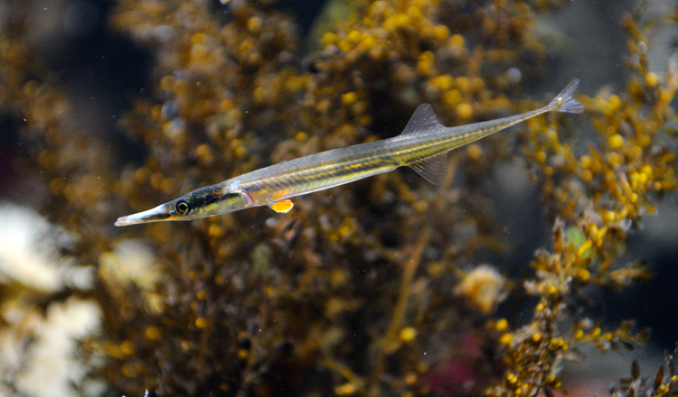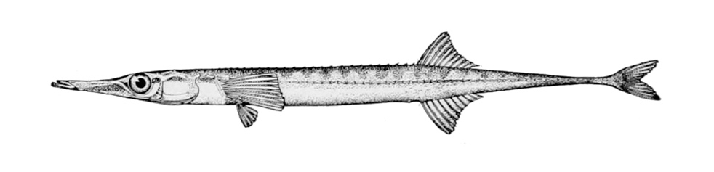

Product | Content | Cat.no.
Genomic DNA Buffer Set | Buffers, including specific lysis buffers for yeast, bacteria, cells, blood, and tissue: Y1, B1, B2, C1, G2, QBT, QC, QF (75 mini-, 25 midi-, or 10 maxipreps) | 19060
QIAGEN Genomic-tip 20/G (1-20μg) | 25 columns | 10223
QIAGEN Proteinase K | 2 ml | 19131

Equipment and Reagents to Be Supplied by User-Tissue

Centrifuge and centrifuge tubes
Homogenizer (Note: Extensive mechanical homogenization can result in shearing of the DNA. This may be critical if the DNA is intended for next generation sequencing library preparation.)
Isopropanol
Ethanol, 70%
Screw-cap tubes (10ml)
Buffers G2, QBT, QC, and QF*
RNase A
Vortexer
Collection tubes
Elution buffer

Reagent volumes/sample, ~20μg
Reagent | Mini
G2 | 2 ml
QBT | 1 ml
QC | 3 ml
QF | 2 ml
Isopropanol | 1.4 ml
70% ethanol | 1 ml
RNase A stock solution | 4 μl | Stock solution (100 mg/ml)  final concentration of 200 μg/ml in G2
Proteinase K stock solution | 100 μl | QIAGEN Proteinase K stock solution

Prepare the tissue:
1, Thoroughly homogenize the tissue mechanically in 2 ml, Buffer G2 (with RNase A) using a homogenizer (cover 2 ml).
2, Transfer the homogenate a 10 ml tube, Add 0.1 ml, QIAGEN Proteinase K stock to the homogenate. Mix well by vortexing.
3, Incubate at 50°C for 2 h.
The length of incubation depends on how well the tissue sample has been homogenized. Lysates should be clear after incubation. If particulate matter is still observed after 2 h, extend the incubation time until the lysate is clear to avoid clogging the QIAGEN Genomic-tip.
Note: If the sample contains particulate matter, centrifuge at 5000 x g for
10 min at 4°C. Discard the pellet and transfer only the supernatant onto the
QIAGEN Genomic-tip.
Optional: Take a 300 μl for an analytical gel.

The sample should be loaded onto the QIAGEN Genomic-tip promptly. If left too long, it may become cloudy due to further precipitation of protein. The sample must then be centrifuged or filtered before loading to prevent clogging of the QIAGEN Genomic-tip.

Isolation of Genomic DNA from Tissue using Genomic-tips
1, Equilibrate a QIAGEN Genomic-tip 20/G, with 1 ml of Buffer QBT, and allow the QIAGEN Genomic-tip to empty by gravity flow.
Place a QIAGEN Genomic-tip over a tube using a tip holder over the waste tray. Equilibrate the QIAGEN Genomic-tip. Allow the QIAGEN Genomic-tip to drain completely. The flow of buffer will stop when the meniscus reaches the upper frit. The frit prevents the QIAGEN Genomic-tip from running dry, allowing it to be left unattended. Do not force out the remaining buffer, as this will necessitate restarting the flow with a syringe and adapter.

2, Vortex the sample for 10 s at maximum speed and apply it to the equilibrated QIAGEN Genomic-tip. Allow it to enter the resin by gravity flow.
Vortexing the genomic DNA has a minimal effect on the size of the DNA, and it accelerates the QIAGEN procedure by eliminating poor flow rates associated with clogging. Once the QIAGEN Genomic-tip is loaded with the clear and particle-free sample, flow will begin unassisted. Allow gravity to determine the flow rate. Flow can be assisted by the application of gentle positive pressure using a disposable syringe and the appropriate adapter. It may also be helpful to dilute the lysate with an equal volume of Buffer QBT prior to loading. When using positive pressure, do not allow the flow rate to exceed 4–10 drops/min.
Optional: Take a 300 μl for an analytical gel.

3, Wash the QIAGEN Genomic-tip with 3 x 1 ml of Buffer QC. Allow Buffer QC to move through the QIAGEN Genomic-tip by gravity flow. Two washes are sufficient to remove all contaminants in the majority of DNA preparations. It is particularly important not to force out residual Buffer QC. Traces of Buffer QC will not affect the elution step.
Optional: Take a 120 μl for an analytical gel.

4, Elute the genomic DNA with 2 x 1 ml of Buffer QF. Place the QIAGEN Genomic-tip over a clean 10 ml collection tube. Use of polycarbonate centrifuge tubes is not recommended as polycarbonate is not resistant to the alcohol used in subsequent steps. Elute with the appropriate volume of Buffer QF, and collect the eluate. Flow begins automatically. Allow the QIAGEN Genomictip to drain by gravity flow. Use of Buffer QF prewarmed to 50°C will increase yields.
Optional: Take a 120 μl for an analytical gel.

5, Precipitate the DNA by adding 1.4 ml (0.7 volumes) room-temperature (15–25°C) isopropanol to the eluted DNA.
Mix and centrifuge immediately at >5000 x g for at least 15 min at 4°C. Carefully remove the supernatant. All solutions should be at room temperature to minimize salt precipitation, although centrifugation is carried out at 4°C to prevent overheating of the sample. A centrifugal force of 5000 x g is the minimal force required for efficient precipitation. Higher g-force is recommended where possible. Isopropanol pellets have a glassy appearance and may be more difficult to see than the fluffy, salt-containing pellets that result from ethanol precipitation. Marking the outside of the tube before centrifugation allows the pellet to be more easily located. Isopropanol pellets are also more loosely attached to the side of the tube, and care should be taken when removing the supernatant.

6, Wash the centrifuged DNA pellet with 1 ml of cold 70% ethanol. Vortex briefly and centrifuge at >5000 x g for 10 min at 4°C. Carefully remove the supernatant without disturbing the pellet. Air-dry for 5–10 min, and resuspend the DNA in 0.1–2 ml of a suitable buffer (e.g., TE buffer, pH 8.0, or 10 mM Tris·Cl, pH 8.5). Dissolve the DNA overnight on a shaker or at 55°C for 1–2 h. The 70% ethanol removes precipitated salt and replaces the isopropanol with the more volatile ethanol, making the DNA easier to redissolve. A second wash with cold 70% ethanol may improve results in more sensitive applications. After careful and complete removal of the ethanol supernatant with a pipet, the pellet should be air-dried briefly before resuspending in a small volume of suitable buffer. Overdrying the pellet will make the DNA difficult to redissolve. Resuspend the DNA pellet by rinsing the walls to recover all the DNA, especially if glass tubes have been used. Pipetting the DNA up and down to promote resuspension may cause shearing and should be avoided.

Analytical gel
To analyze the purification procedure or to find where a problem may have occurred if yields are low, take a proportional aliquot of each of the samples marked in the specific protocol. Precipitate each of the aliquots with 0.7 volumes of isopropanol. Rinse the pellets with 70% ethanol, drain well, and resuspend in 20 μl of TE, pH 8.0. Add the appropriate loading buffer, and use 10 μl of the samples for analysis on a 0.5% agarose gel. Run the gel until the bromophenol blue is near the bottom and stain it briefly in an ethidium bromide solution.

ideal case：
gel analysis of the genomic DNA purification procedure. 1: nuclear
lysate; 2: flow-through fraction; 3: wash fraction; 4: eluate containing pure genomic DNA.
M: markers.

Preparation of enzyme stock solutions
QIAGEN Proteinase K may be purchased from QIAGEN in 2 ml solutions (cat. nos. 19131). QIAGEN Proteinase K solution is at the proper concentration to be used directly in the QIAGEN Genomic DNA protocols and is stable at room temperature (15–25°C) for at least one year.
For longer-term storage, we recommend storing at 2–8°C. If using proteinase K
from another supplier, a 20 mg/ml stock solution in distilled water is generally
recommended.
Before use, RNase A should be added to Buffer G2 (or Buffer B1 for bacterial
DNA isolation) to a concentration of 200 μg/ml and should then be stable for
6 months when stored at 2–8°C.

＊Preparation of buffers
Buffer compositions are given per liter of solution. Do not autoclave buffers; sterilize by filtration instead.
G2: Dissolve 76.42 g guanidine HCl, 11.17 g Na2EDTA·2H2O, and 3.63g Tris base in 600 ml distilled water. Add 250 ml 20% Tween-20 solution and 50 ml 10% Triton X-100 solution. Adjust the pH to 8.0 with NaOH. Adjust the volume to 1 liter with distilled water.
QBT: Dissolve 43.83 g NaCl, 10.46 g MOPS (free acid) in 800 ml distilled water. Adjust the pH to 7.0 with NaOH. Add 150 ml pure isopropanol and 15 ml 10% Triton X-100 solution. Adjust the volume to 1 liter with distilled water.
QC: Dissolve 58.44 g NaCl, 10.46 g MOPS (free acid) in 800 ml distilled
water. Adjust the pH to 7.0 with NaOH. Add 150 ml pure isopropanol.
Adjust the volume to 1 liter with distilled water.
QF: Dissolve 73.05 g NaCl and 6.06 g Tris base in 800 ml distilled water.
Adjust the pH to 8.5 with HCl. Add 150 ml pure isopropanol. Adjust the
volume to 1 liter with distilled water.

